ASSIGNMENT-4

Module - 6 AWS CLOUD

Submitted By – Vikul

Date of Submission -24-05-2024

Submit By – Sheela S

L1 - Create Local git repository and demonstrate

all git reset options and revert. Compare the

differences.

Step-1: Download and install the git in local system.

<https://git-scm.com/downloads>

Step-2: Once you done the installation, we need configure the git,

Configuring username in git

$git config --global user.name<name>

Configuring email id in git

$git config --global user.email<email>

Step-3: Create a folder in local system

Step-4: Open git bash terminal (Right click --> More options --> Click on open git bash here --> Git terminal will open)

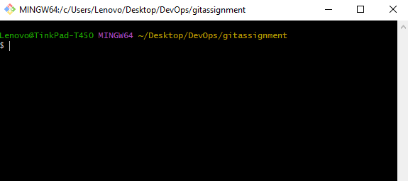

Step-5: Initiate the empty git repository.

$git init

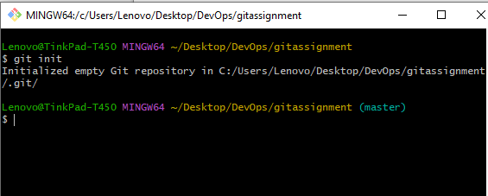

Step-6: Create a file and check the git status. $touch <filename> and $git status

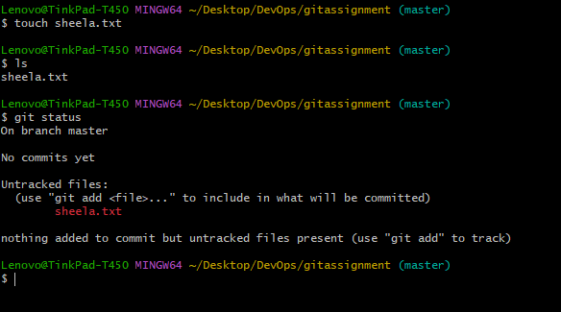

Step-7: Add the file to the staging area $git add,

$git add ., $git add<file name>

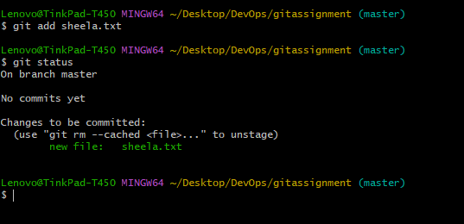

Note: 1. if we see in a file in green colour, this means the files is added in a staging area.

2. if we see in a file in red colour, this means the file is not added in staging area/ unstaged area.

Step-8: Commit the file in local repository.

$git commit -m “<commit message>”

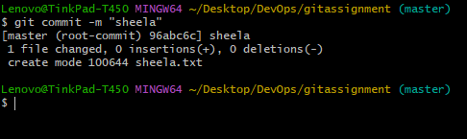

Step-9: Check the committed history and copy the code of committed message.

$git log –oneline

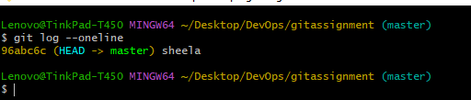

Step-10: reset the previous commit $git reset <head code>

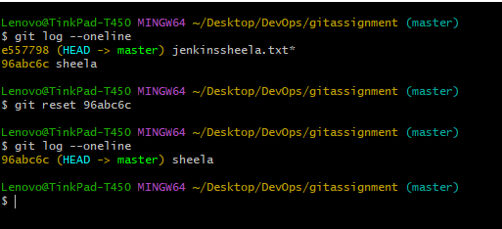 Note:reset is the command we use when we want to move the repository back to a previous commit, discarding any changes made after that commit.

Step-11:revert the last commit $git revert <code id> and check the history.

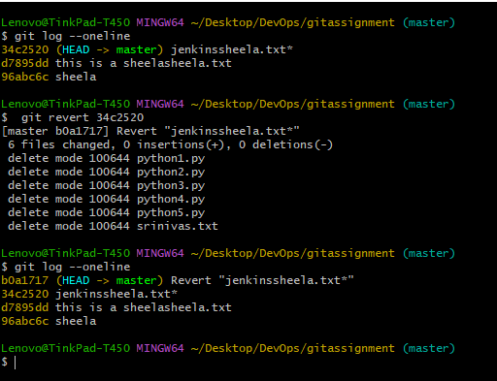 Note: revert is the command we use when we want to take a previous commit and add it as a new commit, keeping the log intact.

Differences between the reset and revert

1. Commit History: Revert preserves the commit history by creating a new commit that undoes the change.

Reset rewrites the commit history by undoing the operations.

1. Safety: Revert is a safer option when working with other developers because it doesn’t affect others’ work.

Reset can cause other developers to lose history and have conflicts in their work.

1. Usage Scenarios: Revert can be used to undo accidental changes or correct changes made while working with others.

Reset is more suitable for editing your local changes and cleaning up the commit history.

L2 - Create Local git repository and demonstrate

git merge and Merge Conflicts with the steps to

resolve merge conflicts.

Step-1: Create a folder

Step-2: Open git bash terminal (Rightclick ---> More options ----> Click on 'Open Gitbash here' ---->

Git terminal will open)

Step-3: Create a folder (mkdir<filename>) and create a file (vim <FileName>)

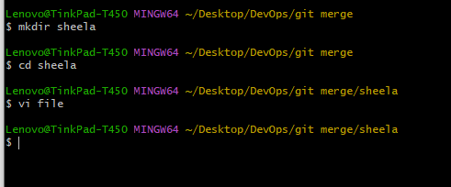

Step-4: Initiate the empty git repository (git init)

Step-5: Check the status of the file (git status)

Step-6: Add the file to the staging area (git add) (git add .) (git add <FileName>)

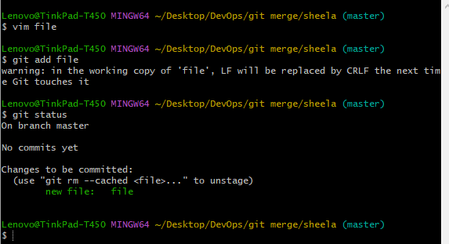

Step-7: Commit the file to local repository (git commit -m "<Enter Commit Message>")

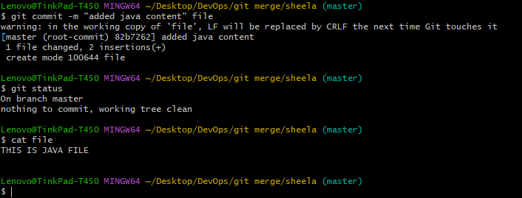

Step-8: Check the git branch and change the branch name.

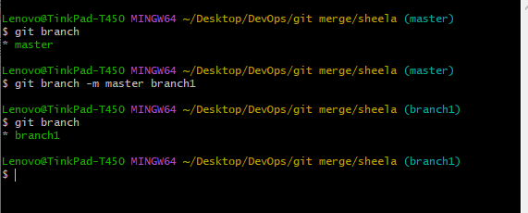

Step-9: switch to branche2, $git checkout -d branche2 and add git.

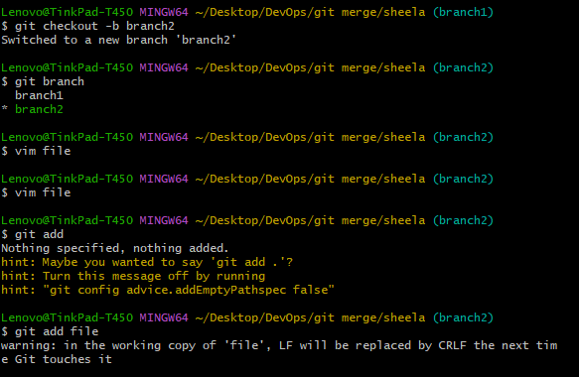

Step-10: Check the status and commit the file.

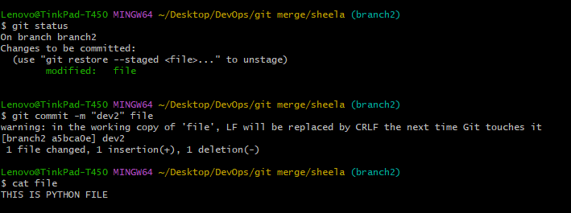

Step-11: Switched to branche2 to branche1.

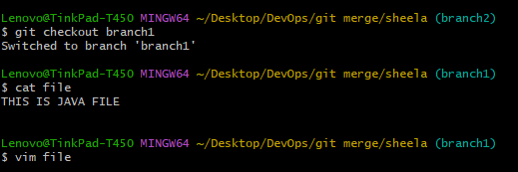

Step-12: Add git file and commit the file.

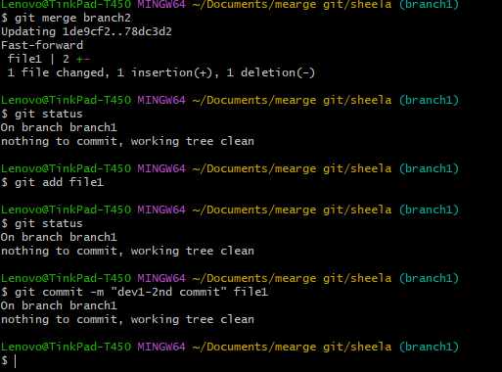

Step-13: Merge branch1 and branch2

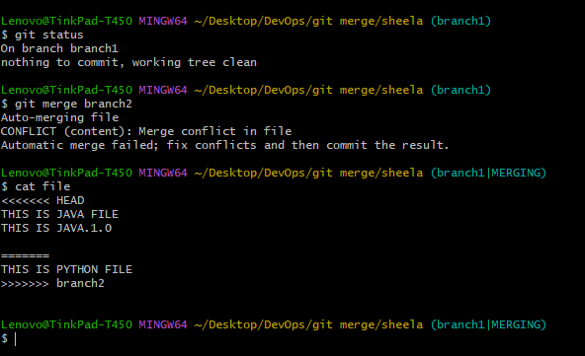

Step-14: resolve merge conflicts

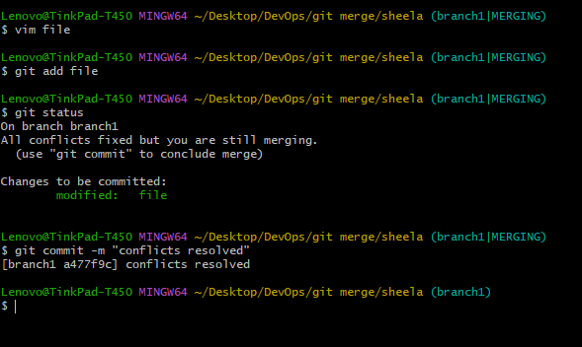

Step-15: Check the git status.

L3 - Using Local and Remote git repositories

demonstrate git pull and git fetch. Compare the

differences.

Step-1: Create a new repository in my github account by the name “git-fetch-pull”.

Step-2: Add the text file is the repository “file1.txt”.

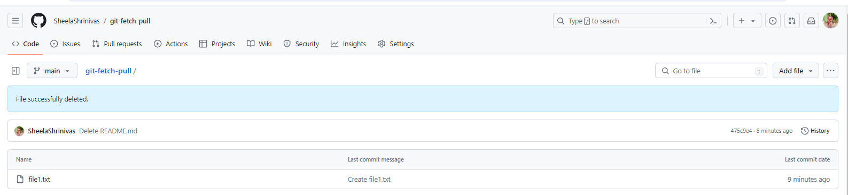

Step-3: Create an empty folder in PC desktop “Fetch Folder”.

Open git bash terminal (Rightclick ---> More options ----> Click on 'Open Gitbash here' ----> Git

terminal will open)

S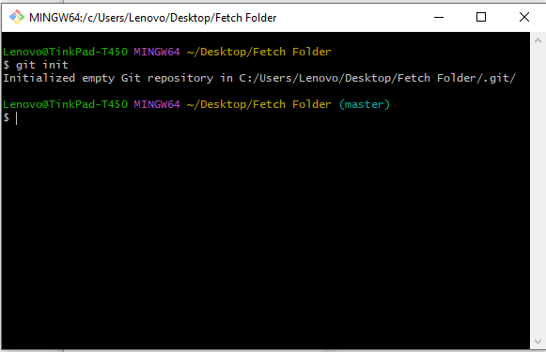tep-4: Initialize an empty repository.

Step-5: Add the remote repository.

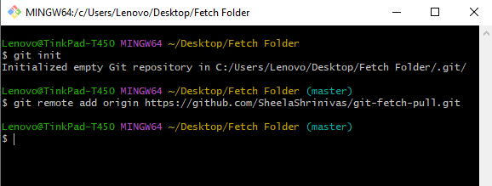

Step-6: Contents to be fetched from this URL.

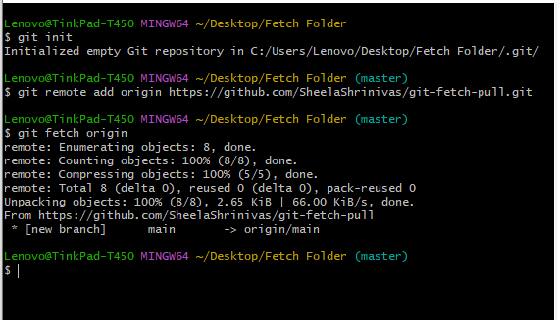

Note: git fetch is copies remote repository in local repository.

Step-7: Content from local repository to working repository, like our folder “fetch folder” in pc desktop b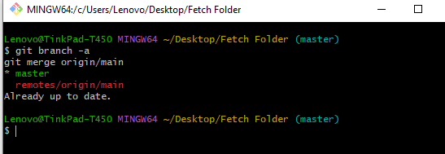y merging.

Note: git merge is brings the content from local repository to working directory, Check the fetch_folder in PC, you will find the file1.txt file from remote repository in this folder.

Git Pull

Step-8: Create an empty folder in PC desktop by “pull folder”.

Open git bash terminal (Rightclick ---> More options ----> Click on 'Open Gitbash here' ----> Git

terminal will open)

Step-9: Git initialization

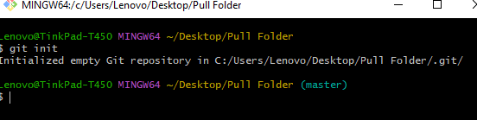

Step-10: Add the remote repository

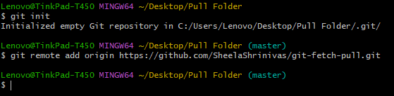

Step-11: Contents are pulled form the URL.

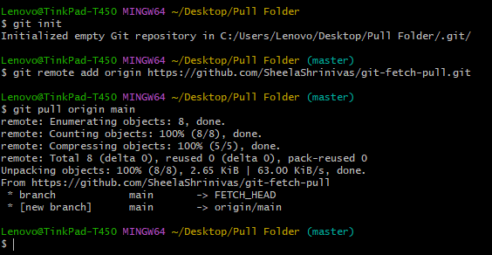

Step-12: git fetch and git merge, Add the “file1.txt” and “file2.txt” files from remote repository in this folder.

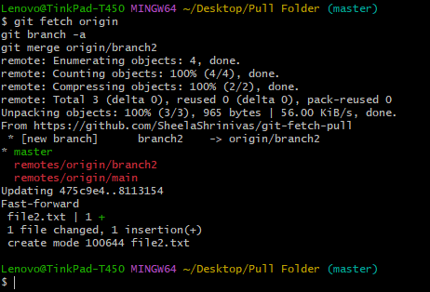

Step-13: git pull, the file1.txt and file2.txt files from remote repository in this folder

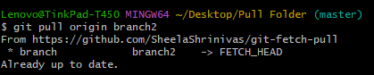

L4 - Clone GitHub repository using Visual Studio

Code IDE.

Step-1: Open Github.com and open our repository.

Step-2: Click on the repository.

Step-3: Select the code option and click on local and copy the URl.

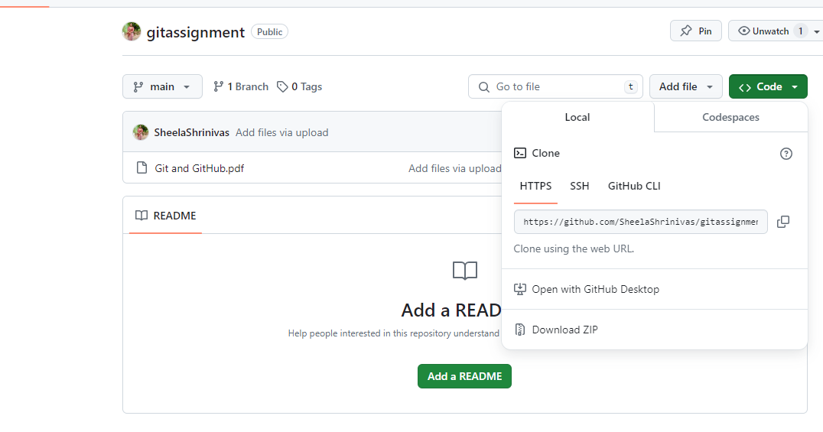  
Step-4: Open the visual studio.

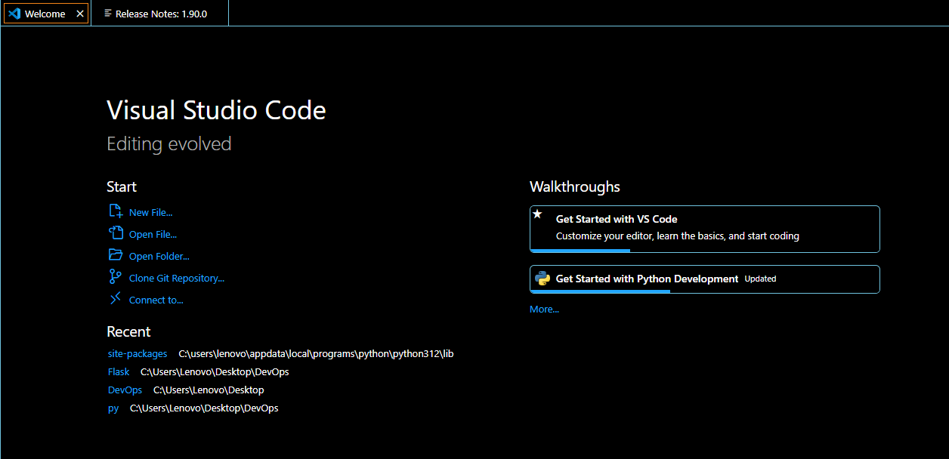

Step-5: Select “clone git repository” and paste the URL and select the local folder.

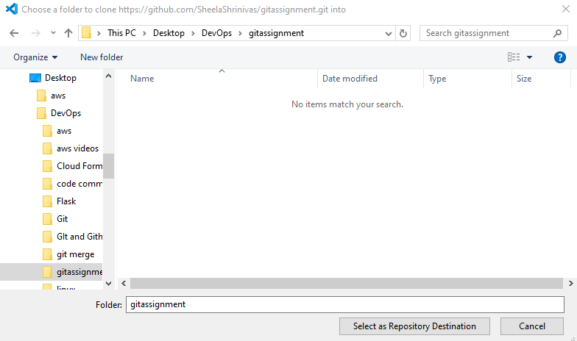

Step-6: Select open it will open the clone repository.

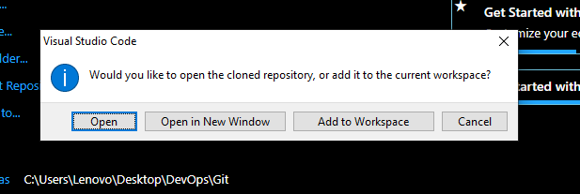



L5 - Push the incremental changes to GitHub

Repository through Visual Studio Code IDE.

Step-1: Open visual studio and select “open folder”.

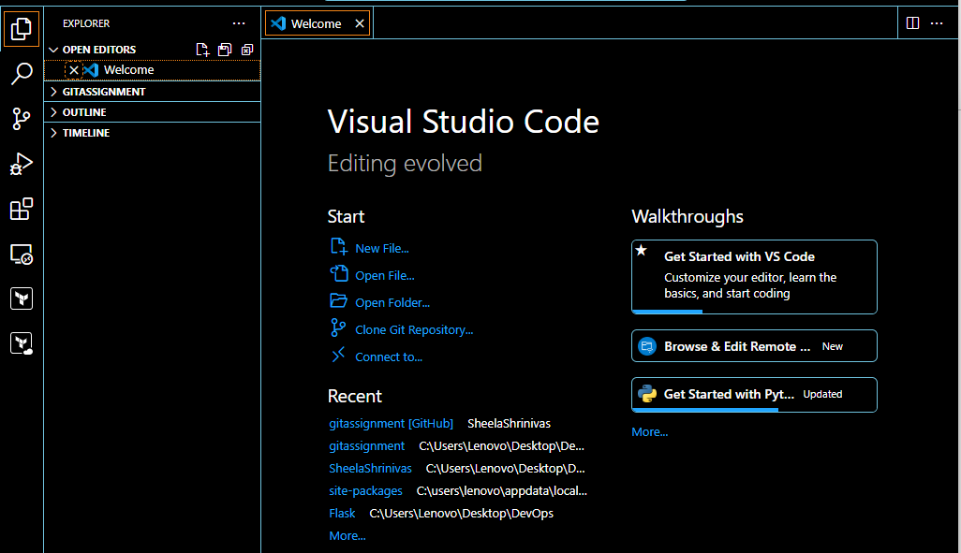

Step-2: Select the git folder.

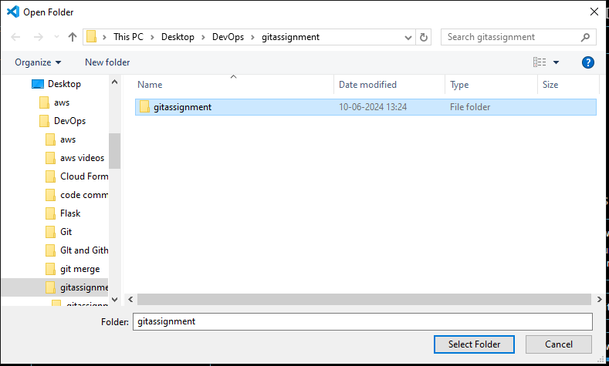

Step-3: Open the file.

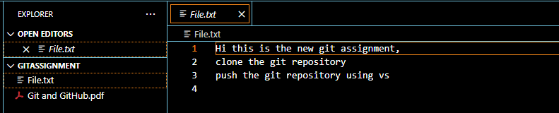

Step-4: I make the changes, not push the repository to github(it shows dot symbol means it’s not push the repository).

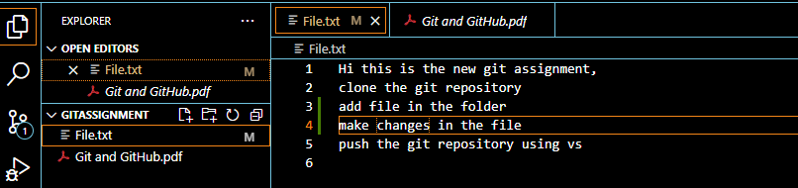

Step-5: Click on the git icon and add commit message, click on commit.

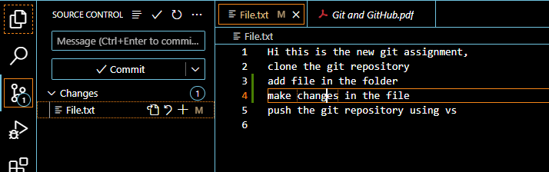

Step-6: Click on the “yes” and click on push to and give the “github URL”

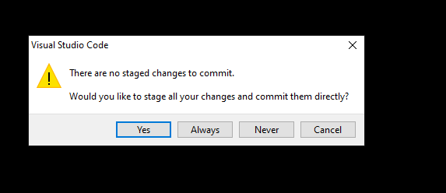

Step-7: Once done the process of push, Authorize git credential, Check the github account.

